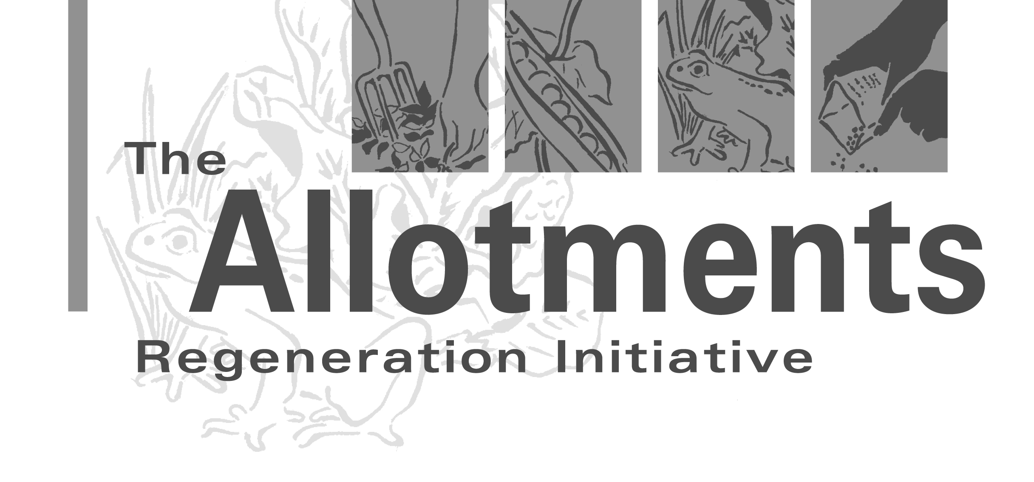

Useful contacts for fundraising
To contact any of the organisations used as case studies in this pack please contact ARI.

Organisation | Area of expertise/advice | Contact details
ARI | Bespoke training courses in fundraising now available. ARI’s mentors can also give you hands-on advice and contacts on fundraising. Other factsheets include toilet installation, health and safety, promotion etc. and can be downloaded from the website. Free postal newsletter. | Tel. 0117 963 1551  www.farmgarden.org.uk/ari  ari@farmgarden.org.uk
NSALG | Can provide legal advice on income generating activities or change of use of allotments. Seed scheme, magazine and insurance scheme for members. Also organise National Allotments Week each year. | Tel. 01536 266 576  www.nsalg.org.uk  natsoc@nsalg.org.uk
Federation of City Farms and Community Gardens (FCFCG) | Advice, support and publications including the Community Garden Starter Pack. | Tel. 0117 923 1800  www.farmgarden.org.uk  admin@farmgarden.org.uk
Fit 4funding | Help and advice for voluntary organisations and community groups who are seeking funding. Information, advice, training and regular funding updates by e-mail. | Tel. 01924 239 063  www.fit4 funding.org.uk
Funding Central | Grants directory website of funding opportunities for community groups and resources to develop sustainable income strategies. | www.fundingcentral.org.uk

Council for Voluntary Service (or similar) | May be able to help you: set up an association; write a constitution; form a business plan (project plan); find out about grants e.g. grant searches using computer databases like ‘Funder Finder’; fill out grant applications; find volunteer teams for your project. | England: NAVCA  Tel. 0114 278 6636  www.navca.org.uk  navca@navca.org.uk | Wales: WCVA  Tel. 029 2043 1700www.wcva.org.uk  www.nicva.org
Council for Voluntary Service (or similar) |  | Northern Ireland: NICVA  Tel. 028 9087 7777 | Scotland: SCVO  Tel. 0131 556 3882  www.scvo.org.uk
Directory of Social Change | Publish books and run courses on fundraising, management, trustees, finance etc. | Tel. 0207 391 4800  www.dsc.org.uk
The Charity Commission | If you decide that you want to set up a charity, this is who to contact. An association should be an adequate structure for most fundraising purposes. | Tel. 0845 300 0218  www.charitycommission.gov.uk
Locality (previously known as Development Trusts Association) | Development trusts are defined as organisations which are “engaged in the economic, environmental and social regeneration of a defined area or community”. Existing development trusts may be able to advise your association on income generation activities or give you advice on setting up your own. | Tel 0845 458 8336  www.locality.org.uk
Permaculture Association | Monthly magazine includes income-generating ideas from gardening, crafts and related activities. | Tel. 0845 458 1805  www.permaculture.org.uk

